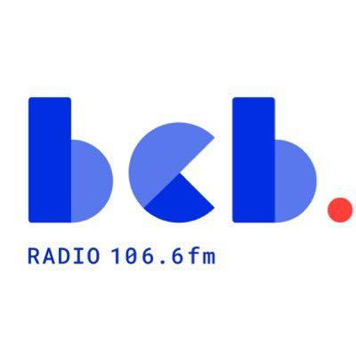

BCB Fundraising and Business Development Worker June 2026
Background Information
Based at: BCB Radio in Bradford, West Yorkshire.
Reports to: BCB Director
Employment Type: Full-Time – 12 month fixed term contract
Salary: NJC SCp 22 - £33,699 plus 5% pension
This new role is funded through a 12-month grant from OFCOM Community Radio Fund.
Who we are:
BCB (Bradford Community Broadcasting) is an inclusive community organisation that uses radio as a tool for social change. For over 30 years we have provided BCB106.6fm, the community radio station for Bradford. We are committed to providing an accessible media platform for local people to broadcast, celebrating the diversity of our community. BCB has a small staff team that supports a large number of volunteers. Our volunteer broadcasters produce and present a wide range of speech and music programmes, reflecting the diversity of Bradford and our communities. BCB is managed by a voluntary management committee, elected from our membership. BCB is based in Bradford city centre at Bradford Arts Centre, St Peters House, 1 Forster Square, Bradford BD1 4TY.
What we are looking for:
We’re looking for an energetic, creative, and proven Fundraising and Business Development Worker to help sustain and grow BCB through grant funding, partnerships, sponsorships, membership schemes, and innovative fundraising strategies.
What you’ll be doing:
The BCB Fundraising and Business Development Worker will lead on all fundraising and income generation activities. This includes developing funding proposals, building relationships with local institutions, businesses and grant-making bodies, and devising and supporting community fundraising campaigns. The role is key to ensuring the long-term financial sustainability of the station. You will also be a key member of the staff team, working alongside other staff to support and deliver the overall mission of BCB.
How to apply:
The application form, the job description and person specification are available to download from the BCB website www.bcbradio.co.uk
You must complete the application form, expanding the boxes as you need to.
NB: Please don’t just send a CV as this will not be considered as an application.
- The closing date for applications is Monday 6 Jul 2026 9am
- Interviews will be held at BCB studios in mid July
If you need any further information about the role please contact the BCB Chair Maureen Grant maureen.grant@bcbradio.co.uk

