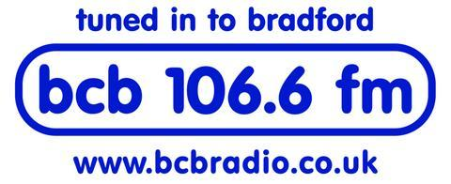

BCB 106.6fm: RADIO PROGRAMME PROPOSAL FORM

Name:

Contact Address:

Phone no: Mobile:

Email Address:

Are you a BCB Member? Yes/No

Please give full details of the programme:

Programme title:

Who is presenting / producing the programme?

Describe the programme content (inc. speech / music ratio)

How would you describe the programme in one sentence /’strap line’?

How long is the programme e.g. 30 mins or 1 hour ?

Do you intend to present the programme live or pre - recorded?

Describe your target audience for the programme - who is it aimed at?

What time of day/day of the week is the best time for the programme to be broadcast? (please give options). Why these times?

How often are you available to present / pre-record the programme?

Weekly ( ) Fortnightly( ) For 4 consecutive weeks ( )

For 6 consecutive weeks ( ) For 8 consecutive weeks ( ) for 12 consecutive weeks ( )

Once every 4 weeks ( ) ‘One Off ‘( ) Other ( ) - please specify

I am unavailable at the following times:

How will you publicise your programme to your target audience?

What training/support will you need from BCB to produce your programmes?

Please specify any training and support needs: Using the broadcast studio ( ) Digital Editing ( ) Interviewing ( ) Scriptwriting ( ) Presentation ( ) Programme production ( )

Other Support needed?

Do you have any special needs we need to be aware of?

Any other information (e.g. any previous media experience? training? etc.)

Are you supplying any supporting information:

A link to a pilot / demo / programme or cart no:

Programme running order attached: Y / N

Signed……………………………………… Date: ………………………….

Please return to Jonathan Pinfield, Broadcast Manager at:

jonathan.pinfield@bcbradio.co.uk

