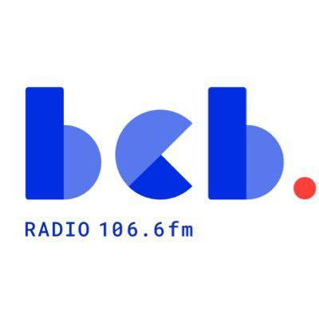

BCB Broadcast Support Worker: Background information June 2026
Based at: BCB Radio, Bradford
Reports to: BCB Broadcast Manager
Employment Type: Part time – 26 hours per week
Fixed term contract:12 months (Maternity Cover)
Salary: NJC SCP6 £25,989 pro rata (Pay award pending) plus 5% pension
Who we are:
BCB (Bradford Community Broadcasting) is an inclusive community organisation that uses radio as a tool for social change. For over 30 years we have provided BCB106.6fm, the community radio station for Bradford. We are committed to providing an accessible media platform for local people to broadcast, celebrating the diversity of our community. BCB has a small staff team that supports a large number of volunteers. Our volunteer broadcasters produce and present a wide range of speech and music programmes, reflecting the diversity of Bradford and our communities. BCB is managed by a voluntary management committee, elected from our membership. BCB is based in Bradford city centre at Bradford Arts Centre, St Peters House, 1 Forster Square, Bradford BD1 4TY.
What we are looking for:
We’re looking for an energetic, creative, organised, proactive Broadcast Support Worker to join our staff team, supporting the day to day operation of our speech-based magazine format radio programmes. This is a 12 month maternity cover. Your main role will be focused on booking guests for the daily programmes, About Bradford and Bradford and Beyond, and preparing the running orders and supporting materials for the presenters. Working with other members of the BCB staff team and volunteers, you will be producing relevant, informative and engaging programmes in line with BCB values and editorial policies.
How to apply:
The application form, the job description and person specification are available to download from the BCB website. You must complete the application form, expanding the boxes as you need to.
NB: Please don’t just send a CV as this will not be considered as an application.
- The closing date for applications is Sunday 21 June (midnight)
- Interviews will be held at BCB studios on Friday 26 June
If you need any further information about the role please contact the BCB Chair Maureen Grant maureen.grant@bcbradio.co.uk

